Project Name: | CPS-Tec Migrate FIDs SAPUF to Cyberark - TCORPORATIVA (C430)
Project No: | P0149779 - 145791
Document Owner  (Name, SOE ID): | Miguel Angel Hernandez Hernandez  MH12060

GCT Technical Design (TD) – High Level Template
Assumptions, Constraints, and Decisions
Technical Approach
Database Design / Layout
Design Considerations

This page displays the U.S. Export Notice. Do NOT delete.

Table of Contents
Document Change Control 4
Template Introduction and Instruction 5
Review and Approval Table 6
1 Assumptions, Constraints and Decisions 7
1.1 Assumptions (Required) 7
1.2 Constraints (Required) 7
1.3 Decisions (Required) 7
2 Technical Approach (Required) 8
3 Database Design / Layout (Required) 10
4 Design Considerations (Required) 11
4.1 Design Considerations for Non-Functional Requirements 11
4.2 Internationalization, Localization, and Legal/Regulatory/Cultural Impacts 11
5 High Level to Detailed Designs Correlation (Required) 12
6 Additional Technical Design Deliverables 14
7 Appendix 16

Document Change Control

Version No. | Revised By | Revision Date | Sections | Description of Change(s)
V1 | Migue Angel Hernandez Hernandez | mm/dd/yyyy | X.Y | Initial Draft

Template Introduction and Instruction
Don’t delete this section.
This template is based on the Technical Design Playbook. Refer the Playbook to get the details of how to execute Technical Design and fill out this Technical Design artifact.

The sections required to be completed are marked as “Required” in this template:
- All “Required” sections need to be completed.
- If a “Required” section is not applicable for the project, clear explanation or reason is required for non-applicability. Just putting NA will not be sufficient.
- If a section is not marked as “Required”, then putting “NA” is okay. No additional explanation will be required
- No section should be left blank.
Technical Design is the elaboration of Functional and Non-Functional Requirements. Typically, it is approached by first developing a logical design and then a physical design.
- A logical design consists of:
  - Assumptions / Constraints / Decisions
  - Technical Approach*
  - Database Design / Layout
  - Design Considerations*
- A physical design consists of:
  - Detailed Design
*Note: The elaboration of Non-Functional Requirements can be part of the Technical Approach. However, often times, a NFR is best clarified using “ilities” and can be documented as part of the Design Considerations.

While completing this document, keep in mind that “Good enough is good enough.”
“Good enough is good enough” - is a best practice for software design. It favors quick, simple and yet potentially extensible deliverables over elaborate complete system designs. Once the simple design is deployed, it can then evolve as needed, driven by user requirements.

Good enough designs meet criteria like:
      - It has sufficient benefits.
      - It has no critical problems.
      - The benefits sufficiently outweigh the problems.
      - In the present situation, and all things considered, further improvement would be more harmful than helpful.
Which Technical Design artifact template(s) do I use?
There are two versions:
- The first version has the logical design and physical design combined. Ideally, you would use this version for single system/group impacts.
- This version with two templates (Technical Design – High Level.doc and Technical Design – Detailed .doc) is used when multiple systems/groups are impacted. This allows each group to easily collaborate by sharing one logical design (Technical Design – High Level.doc) and having their own physical design (Technical Design – Detailed.doc). If more than one system owned by a Development group (i.e. having the same System Analyst & Designers) is impacted in a project, it can use one Tech Design – Detailed document to capture all the detailed designs for the particular Development group. ALL the sections of the Tech Design – Detailed Template will be repeated for each system without any omission in the document. System Analyst is responsible to replicate the sections for EACH system.

Naming Convention
- Document Name – Team Name – P# (Ex. Technical Design - High Level – Team X – PNNNNNNN) or if not team specific just include document name and P# (Ex. BRD – PNNNNNNN). ReferGCT PM & SDLC Playbook.

Review and Approval Table

For Applications In Scope for Project Architectural Risk Analysis (ARA), the Project Information Security Officer (ISO) will also review and approve the Technical Design. For other applications, TISO may review the Technical Design as identified in the ISR Form.

Prepared By: | Name: | Miguel Angel Hernandez Hernandez | Date:
REVIEW
Reviewed By: | Name: | Rosa María de Lourdes Arauz Hernandez | Date:
Reviewed By: | Name: |  | Date:
Reviewed By: | Name: |  | Date:
Reviewed By: | Name: |  | Date:
APPROVAL
Approved By: | Name: | Pedro Enrique Gonzalez Jaramillo | Date:
Approved By: | Name: |  | Date:
Approved By: | Name: |  | Date:
Approved By: | Name: |  | Date:

Assumptions, Constraints and Decisions

Assumptions (Required)
Es necesario que la aplicación C430_000 Corporate Card System Server que usa SAPUF como mecanismo para administrar la contraseña de las ID funcionales, se migre al Sistema Cyberark, por lo que es obligatorio que la aplicación se registre en Citi System Inventory (CSI) y la ID funcional es necesario se registre en el Repositorio central de ISA (CISAR).
En un inicio seguirá en operación el sistema SAPUF, y se podrá realizar un switch a este Sistema en caso de encontrar alguna limitante inicialmente en ambiente Productivo

Constraints (Required)
- Recursos disponibles para el desarrollo de las aplicaciones. Como puede ser obtener el licenciamiento del software de desarrollo:
  - Visual Studio 2012
  - AdminStudio/Install Shield 2010
  - Spread for WinForms 7 v3
- Limitaciones presupuestarias:
  - Existen limitaciones presupuestarias ya que los fondos ya están disponibles.

Decisions (Required)

- Se implementará un “switch” en el sistema C430 para poder elegir con qué proceso obtener los datos de acceso a la BD (CyberArk ó SAPUF).
- El “switch” que se implementará tendrá la función de elegir qué proceso utilizar para obtener los datos de acceso a la BD, esto mediante la utilización de una bandera que los usuarios podrán modificar.
  - Si el valor es 1 (true) – Se elegirá obtener los datos de acceso a la BD vía CyberArk.
  - Si el valor es 0 (false) – Se elegirá obtener los datos de acceso a la BD vía SAPUF.

Technical Approach (Required)
Representation of how the system is structured (e.g. Logical Architecture Diagram or UML Package Diagram)

Representation of process flow (e.g. UML Sequence Diagrams / Activity Diagrams)

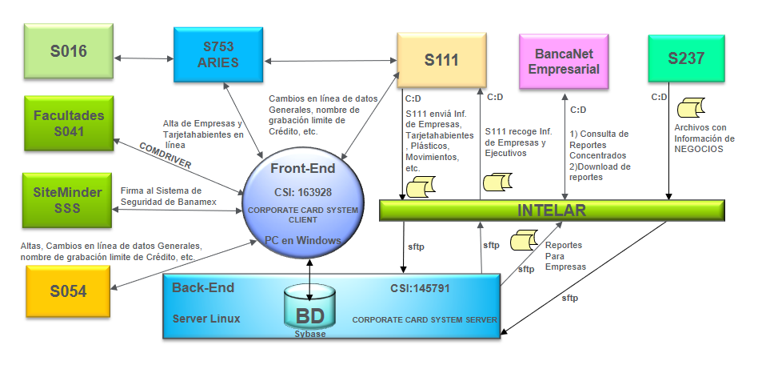
Figure 1. C430 Tarjeta Ejecutiva – Diagrama de bloque.
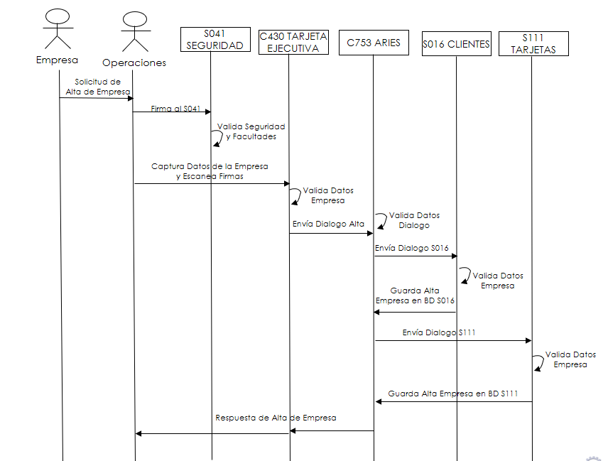
Figure 2 Diagrama de Secuencia Sistema C430: Altas de empresas.

Database Design / Layout (Required)
No Aplica. No se realizan modificaciones a la Base de Datos.

Design Considerations (Required)

Design Considerations for Non-Functional Requirements
Elaboration of the Non-Functional Requirements (NFRs) and can be clarified using “ilities.”. Evaluate the most frequently used NFRs from the table below and define technical solution for applicable NFRs. Refer to the Technical Design Playbook for details on the definition, example and additional NFRs.

Non Functional Requirements | Definition
Usability | No aplica ya que este Proyecto es un Proyecto de migracion, para la administración de FIDs del sistema SAPUF a CyberArk por lo que no se le va a agregar o modificar la funcionalidad actual del Sistema C430.
Reliability | Se busca robustecer la seguridad en la administración de los FIDs en el sistema C430 al reemplazar el uso de SAPUF por CyberArk.
Performability | El tiempo de respuesta actual del sistema C430, no debe verse impactado negativamente por esta migración.
Supportability | Se elimina el riesgo operacional, ya que no se tiene un contrato de soporte con el actual proveedor de SAPUF.  Implementar Acceso/Autenticación a la Base de Datos mediante CyberArt o SAPUF a travéz de una bandera de configuración

Internationalization, Localization, and Legal/Regulatory/Cultural Impacts

Este documento no modifica los lineamientos gubernamentales que estan aplicados en el “Sistema C430” actualmente y es acorde con las instrucciones de la comisión bancaria y de valores.

High Level to Detailed Designs Correlation (Required)
Add below a correlation table to map all Use Cases or Functionalities to various detailed design documents to be created. Individual detailed design will be created for one application or System.

Identify system for which Tech Design – Detailed will NOT be created as per the criteria in the Tech Design Playbook. In case it will NOT be created for a system, provide the reason and explanation in the Comments section of the table
Insert more columns if required.

Identify and provide comments if more than one system owned by a Development group (i.e. having the same System Analyst & Designers) and if the Technical Design – Detailed will be created in one document. All the sections will be repeated for each System. The Tech Design – Detailed cover page should clearly show the name of the systems.

Identify if code review is required based on if a new CSI applications and applications which are identified in CSI have any of the following attributes:
- IS Risk = high
- Business criticality = high
- SOX indicator = SOX critical
- Data Privacy indicator = yes – confidential PII

Identify if “Application Recovery Plan (ARP)” will be created/updated for the application. The ARP needs to be updated if a “Design Charter” is created for the project. Refer the GCT PM & SDLC Procedure for the criteria.

Identify if Development Integration Testing will be done by the project and which applications are part of the testing. The identification is done for better development planning and no further deliverables are required.

Impacted Applications: Applications which will make changes for the project.
Impacted Countries: Identify the countries where the project will deploy the code.
Connected Applications: Identify OTHER upstream and downstream applications connected to “Impacted Applications” and are impacted by the change. If no Connected Applications, put “None”.
Support Applications: Applications which will provide support to the Impacted Applications in the project and will NOT make any changes. If no Support Applications, put “None”.

Impacted Countries
Impacted Application → | C430-000 145791 | C430-001 145791 | << Application Name 3 / CSI ID>> | << Application Name 4 / CSI ID>> | << Application Name 5 / CSI ID>>
Connected Applications | Intelar 170770
Support Applications | Se cuenta con soporte de las aplicaciones Intelar y TANDEM
Tech Design - Detailed Required (Y/N) | Y | Y
Explanation WHY if a Tech Design – Detailed is NOT required
Identify and provide comments if more than one Technical Design – Detailed will be created in one document (E.g. System 3 & System 4 owned by one Development group and will create one document.)
Code review Required (Y / N) | Y | Y
Application Recovery Plan (ARP) created/updated (Y/N) | N | N
Development Integration Testing (DIT) conducted (Y/N) | Y | Y
Use Cases / Functionality | Y | Y
CU001 FID’S Validation (Front) |  | Y
CU002 FID’S Validation (Batch) | Y
Use case N

Additional Technical Design Deliverables

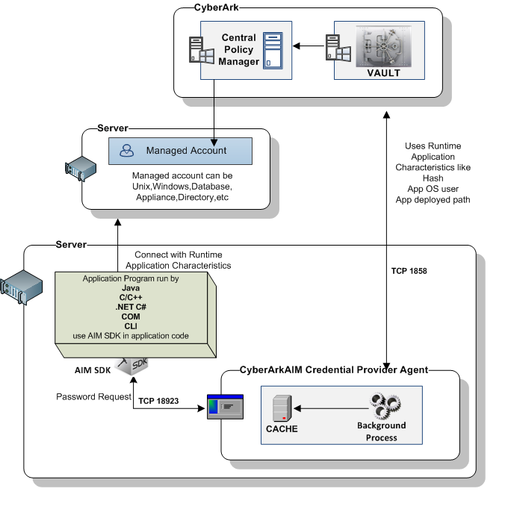
Figure 3 CyberArk Worflow

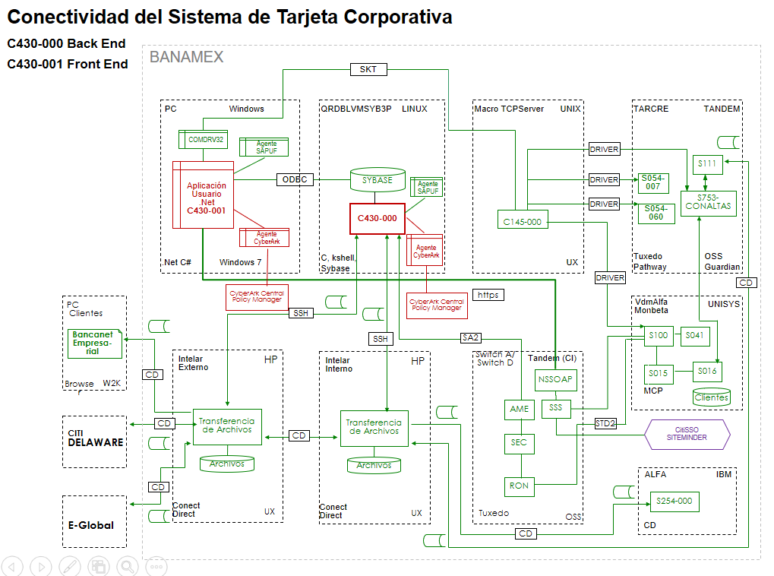
Figure 4 Diagrama de Arquitectura con implementación de CyberArk

Appendix

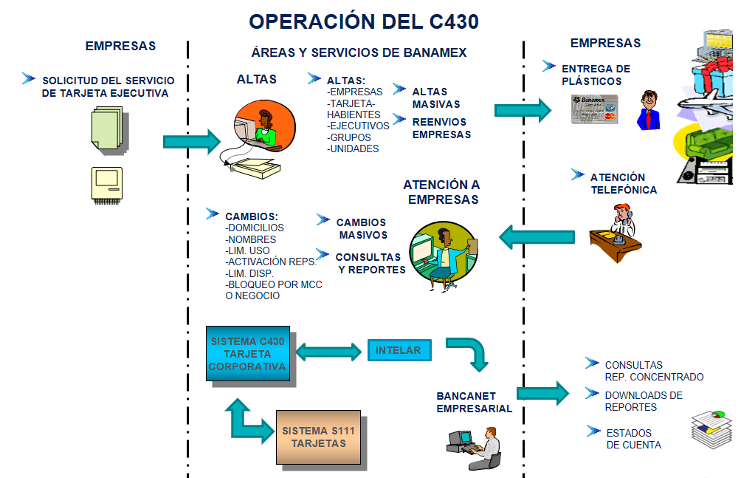
Figure 5 Diagrama de Negocio
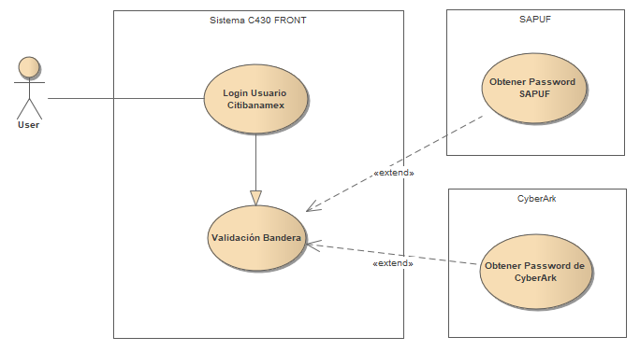
Figure 6. CU001. Diagrama de Caso de Uso de Validación Front.

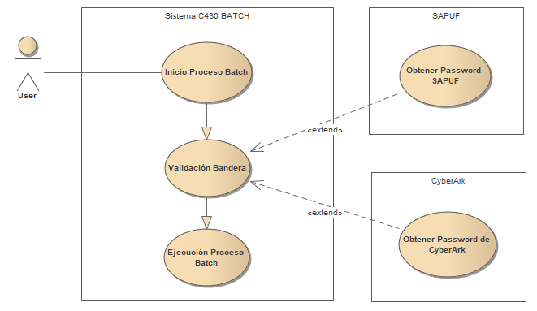
Figure 7. CU002. Diagrama de Caso de Uso de Validación Batch.

Use Case List

ID | Name | Parent Folder | Description
 | FID´s Validation | Use Cases | CU001 The user will sign in to the application and completing its validation process will send the required information to the CyberArk library to retrieve the password of the database engine.
 | FID´s Validation | Use Cases | CU002 The user will sign in to the application and the batch process will send the required information to the CyberArk library to retrieve the password of the database engine.

